**Dr. Rabie Mansour Ali**

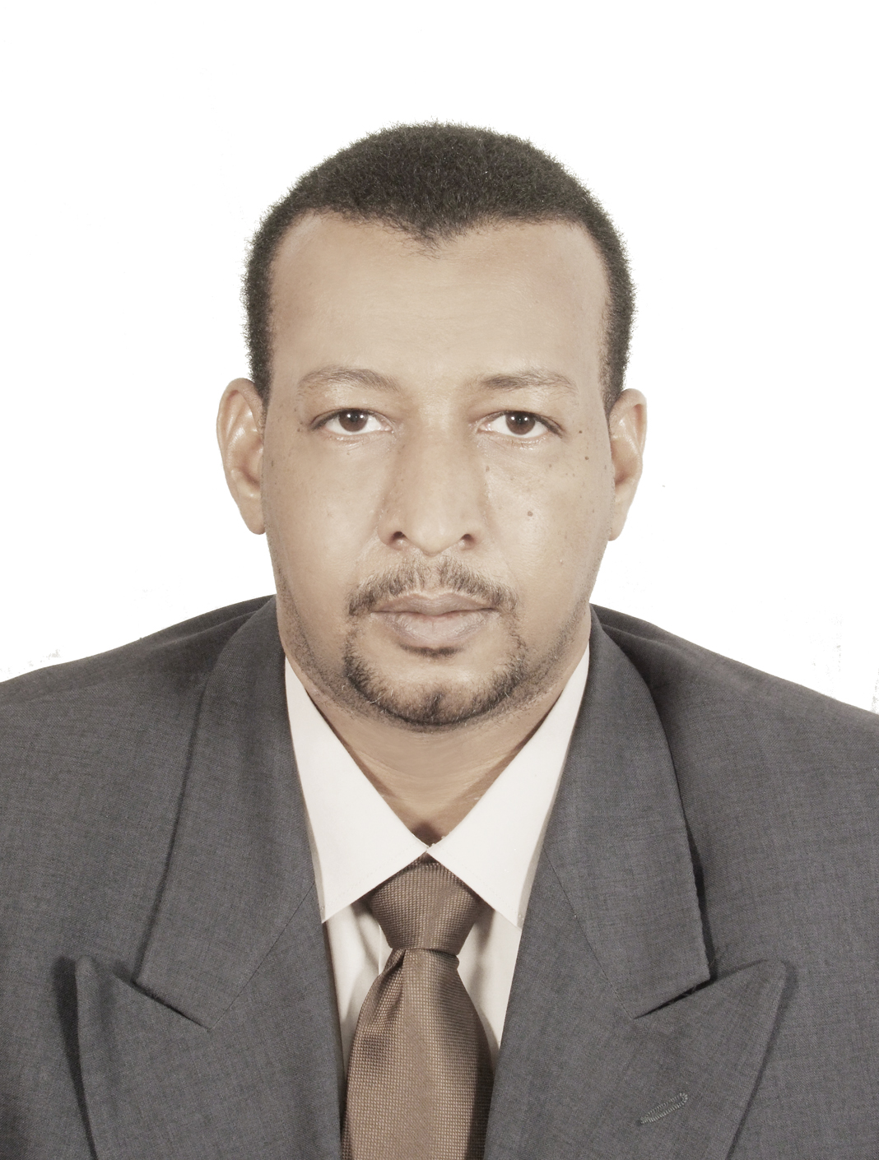

***AL-BAHA UNIVERSITY-KSA***

**Mobile Phone: 00966-0535946351**

**rmelbadry@yahoo.com**

***Objective****: MD in Clinical Pathology(Histopathology,Hematology).*

***Education:***

* ***Medical Doctorate in Clinical Pathology***, Histopathology, Microbiology, Hematology, Biochemistry Faculty of Medicine, University of Gezira, Medani, Sudan, July 2010.
* ***Bachelor of Medicine and Surgery***, College of Medicine and Health Sciences, University of Izhevsk state(Russia)1999.

***Professional Experience:***

***Assistant professor of clinical pathology ,faculty of medicine, Albaha university.***

***Consultant of clinical pathology, Omdurman maternity hospital, FMOH Sudan.***

*August2010 - August2013.*

***Assistant professor of clinical pathology(Part-Timer),University of Dongola ,faculty of medicine .****August 2010- August2013.*

***Resident doctor of Clinical Pathology, University of Gezira Medical Laboratory****, Medani, Sudan, August 2005-2010.*

* Receive advanced practical training in microbiology, hematology, histology, chemical pathology and review interpretations of slides by lab technicians.
* Take bone marrow aspiration, trephine biopsy, fine needle aspiration and conduct effective diagnosis for diseases such leukemia and other abnormalities.
* Conduct effective presentations and lectures in the different branches of pathology for colleagues, under the supervision of professors.
* Teach undergraduate medical students courses in pathology as well as laboratory sciences and improved their academic and practical attainment.

### ***Knowledge & Abilities:***

* Excellent skills in successfully managing as well as completing several projects simultaneously and achieving objectives within specifications.
* Trained in total quality management in laboratories, clinics and hospitals.
* Capable of coordinating effectively with different departments/teams, and execute short and long term strategic plans, either working autonomously or as part of a team.
* Effective skills in interacting with professionals at all organizational levels.
* Strong analytical and assessment skills.

### ***Written & Verbal Communication Skills*:**

* Able to communicate ideas and concepts effectively, both orally and in writing.
* Interact effectively with government, NGOs and community organizations.
* Excellent interpersonal skills.

### ***Languages:***

* Good working knowledge of English
* Good working knowledge of Russian
* Native fluency in Arabic

### ***Membership in Organizations:***

* Sudan Medical Council, Member 2000-present.
* Sudan Medical Union, Member 2000-present.

### ***Other Information:***

* A goal-driven professional who believes in life-long learning.
* Energetic, collaborative professional.
* Sudanese nationality

